**CONSUMING PHP REST API FROM ANGULAR 5**

IN ORDER TO ACHIEVE THIS YOU HAVE TO CREATE A NEW SERVICE RUNNING ***ng generate service ..***

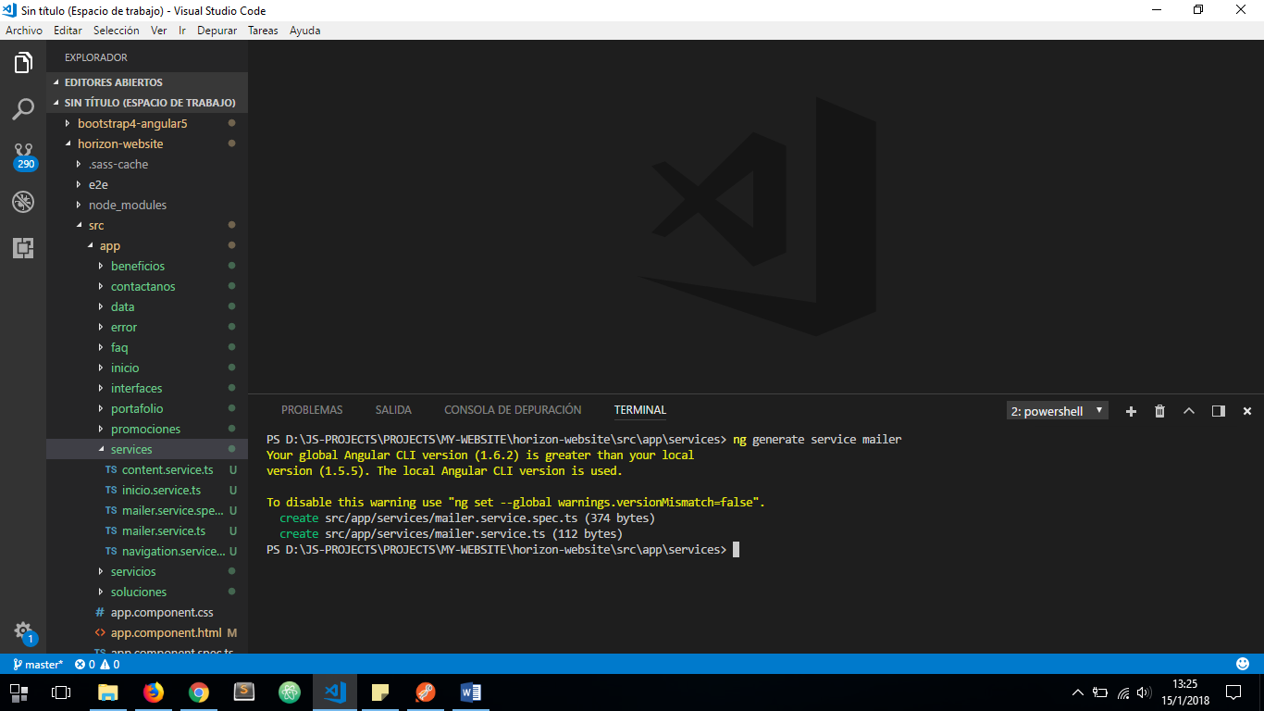

CREATING A REST URL CONTAINER ***src/app/res/rest-url.ts***:

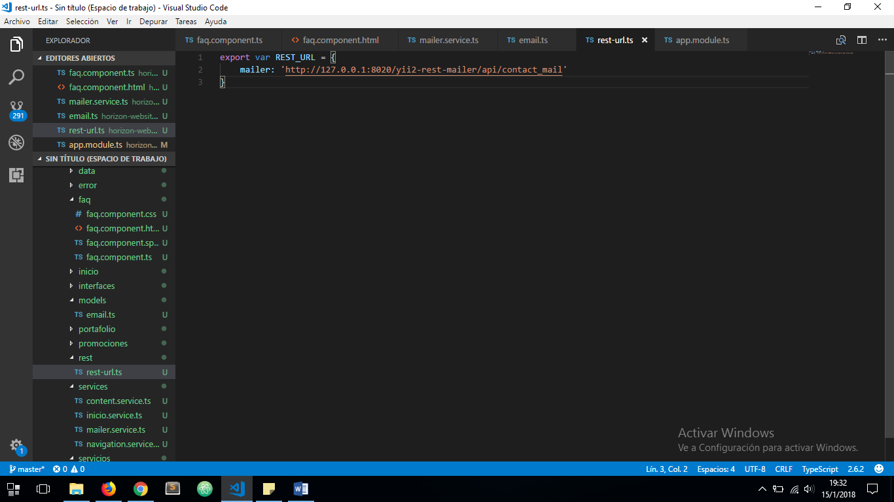

CREATING A NEW MODEL ***src/models/email.ts***:

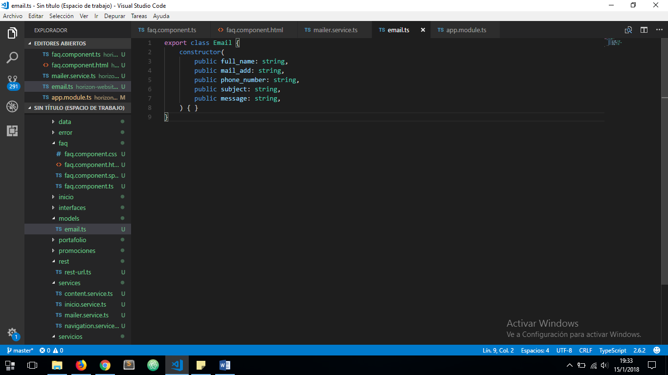

CONFIGURING OUR MAILER SERVICE ***src/app/services/Mailer.service.ts***:

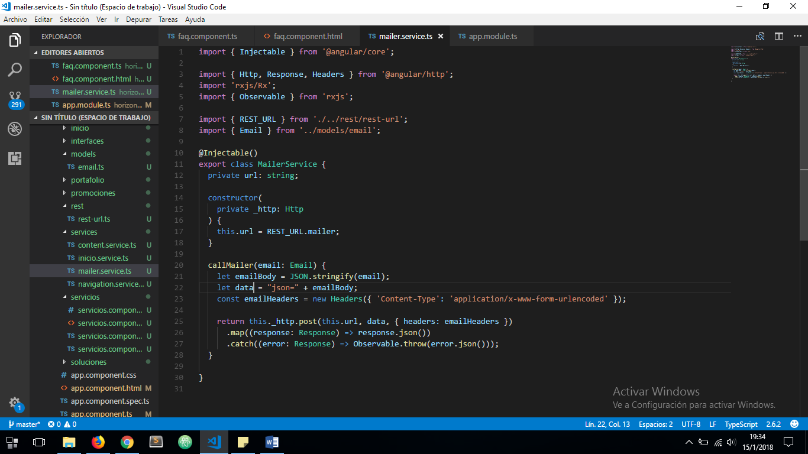

ADDING ***FormsModule*** AND ***HttpModule*** TO IMPORT IN ***app.module.ts***

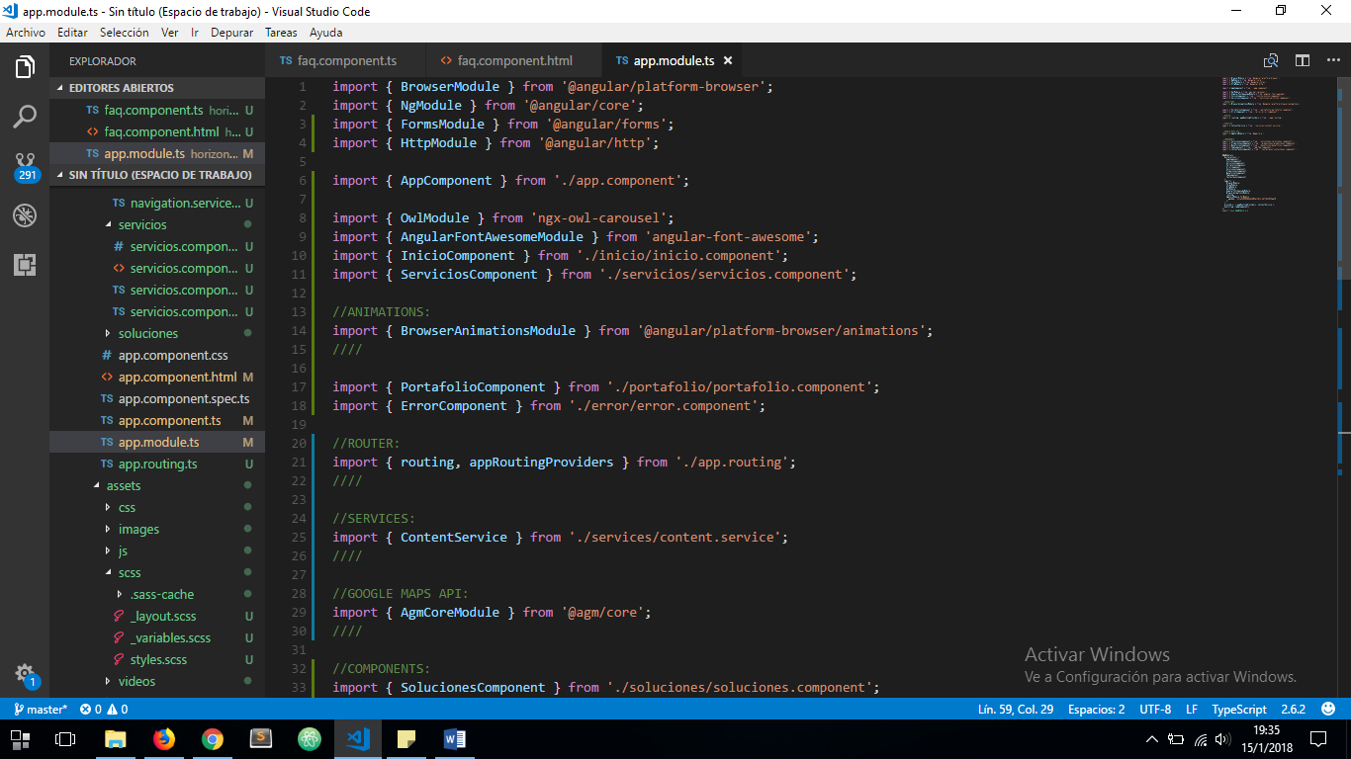

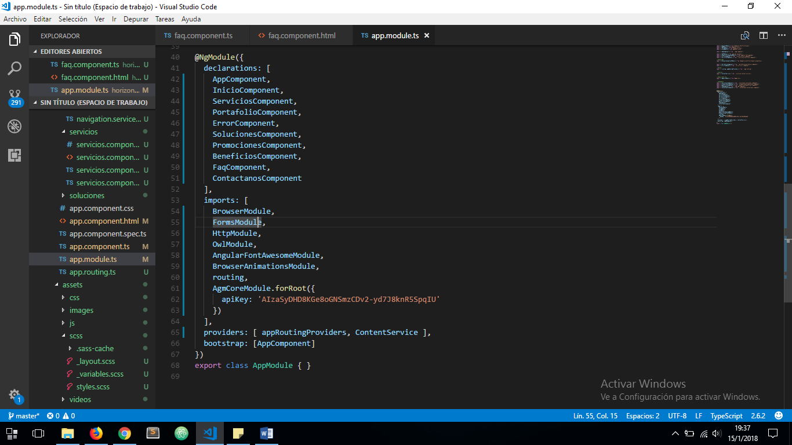

OUR COMPONENT WHICH WILL CONSUME MAILER SERVICE ***faq.component.ts***:

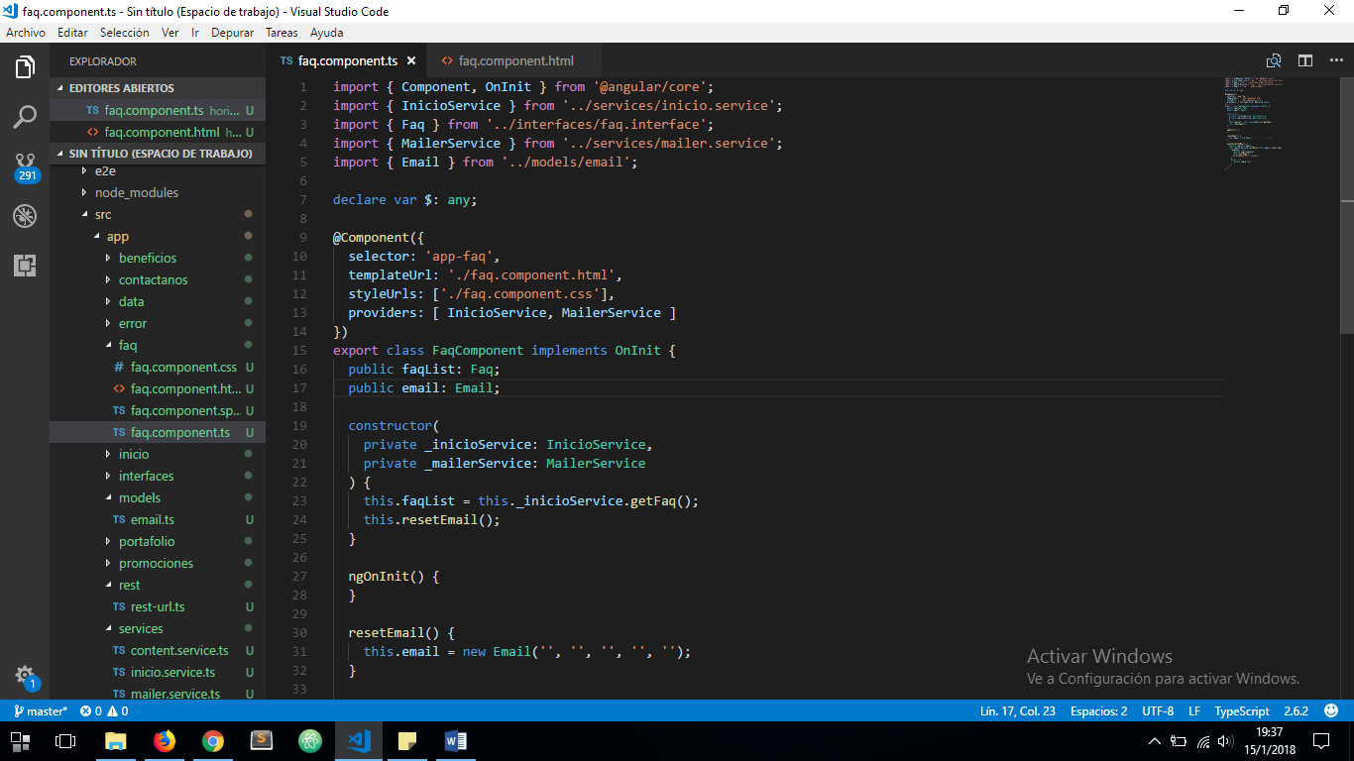

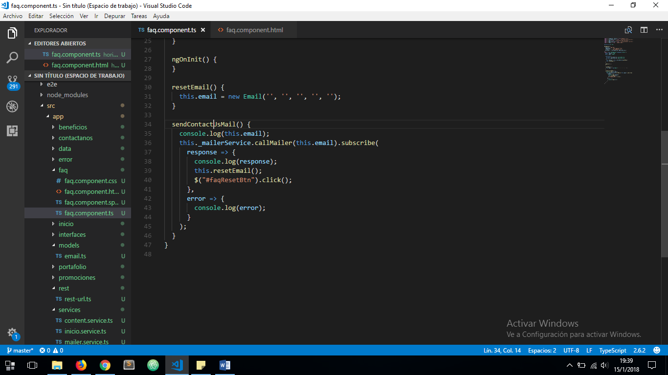

COMPONENT TEMPLATE ***faq.component.html*** USING ***ngModel*** DIRECTIVE:

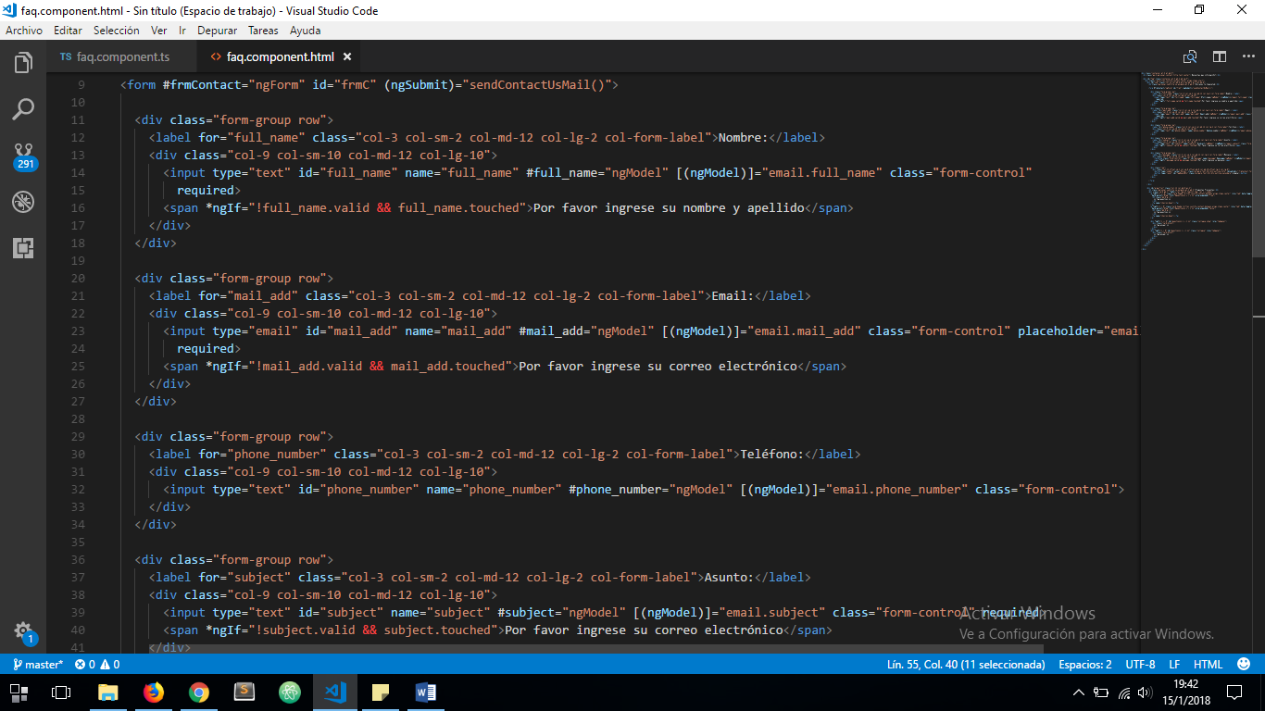

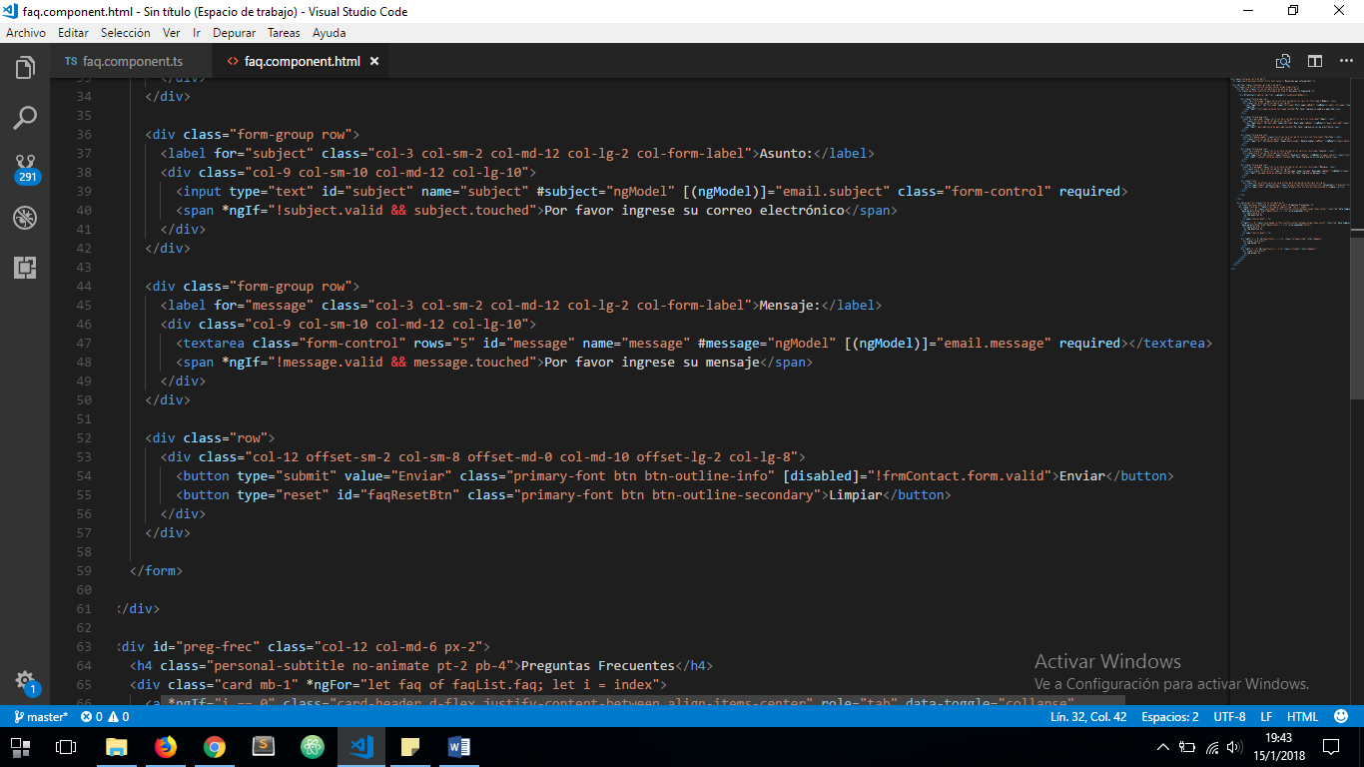

LET’S TRY IT:

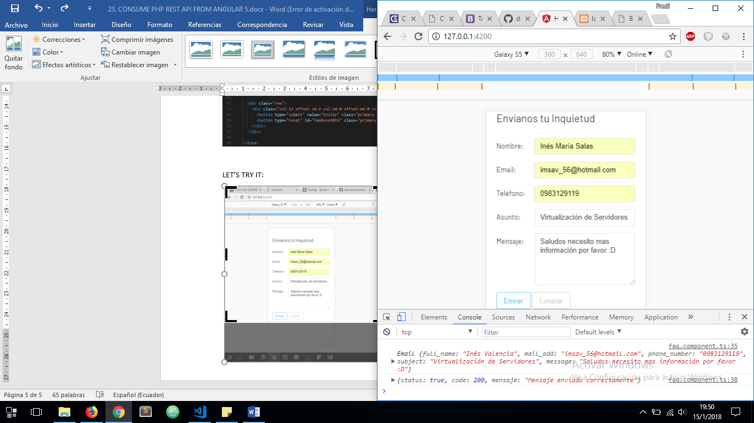

THE RESULT IS:

